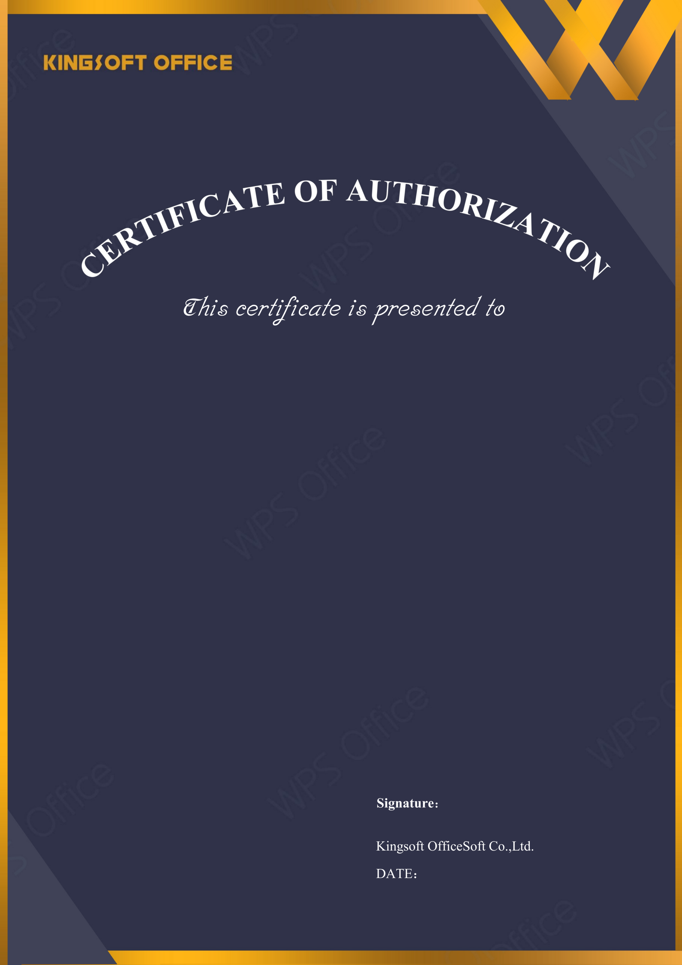
2027-03-20
HDFC ERGO General Insurance Company Ltd.

Licensed Software: | WPS Office for Business
License Type: | Quantity License
Licensed Quantity: | 500
License Start Date: | 2026-03-20
License Expire Date: | 2027-03-20
Upgrade Deadline: | 2027-03-20
License Number: | WZK41-BUB4X-P6TZT-U62WZ-TFPGX



